**Practical No 06**

**Aim : Implement Bucketing using Hive**

1. **Create a database called “show_bucket” , Create a table named “emp_demo” in show_bucket.db. Assume appropriate columns**

sudo ./hive

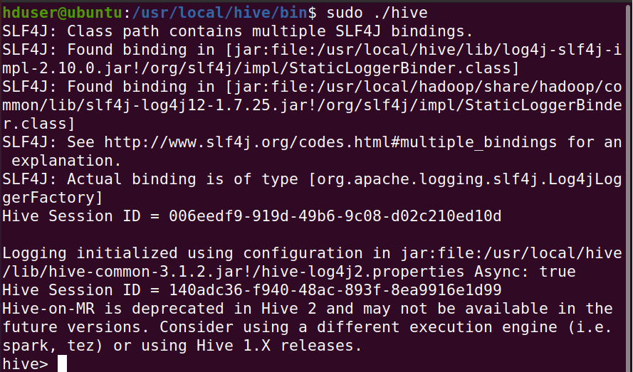

create database show_bucket;

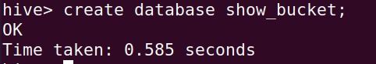

show databases;

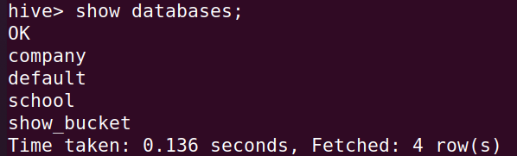

use show_bucket;



create table emp_demo (id int, name string, salary int)

row format delimited

fields terminated by ',';

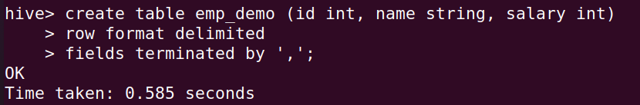

show tables;

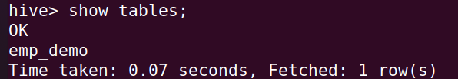

1. **Create emp_details.txt, assume appropriate data. Load data in emp_demo table from file emp_details.txt.**

quit;

sudo nano emp_details.txt

1,Harsh,95000

2,Ramdas,85000

3,Omkar,90000

4,Shubham,80000

5,Kaushal,75000

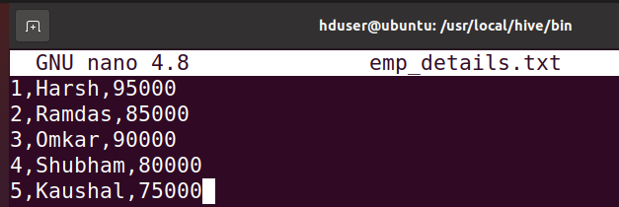

ls

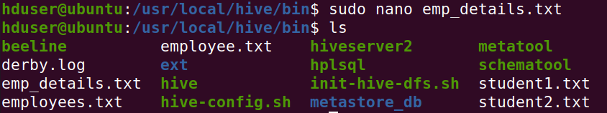

sudo ./hive

use show_bucket

load data local inpath 'emp_details.txt' into table emp_demo;

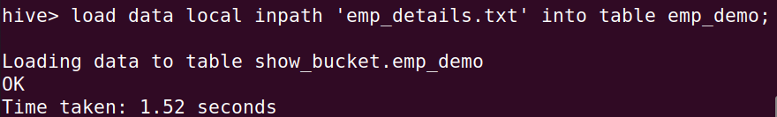

1. **Verify the employee table along with its schema from terminal as well as browser 40.**

DESCRIBE emp_demo;

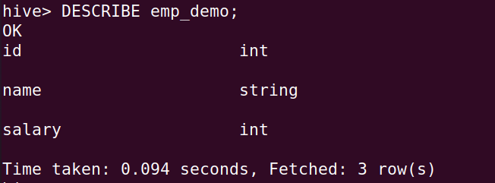

1. **Enable the bucketing, Create a bucketing table “emp_bucket”**

set hive.enforce.bucketing = true;



create table emp_bucket (id int, name string, salary int)

row format delimited

fields terminated by ',';

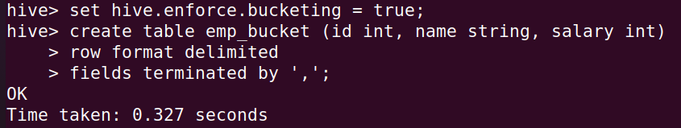

/user/hive/warehouse/show_bucket.db

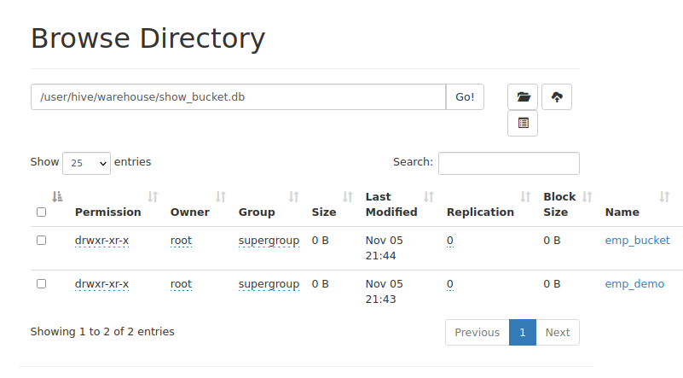

1. **Insert the data of emp_demo table into the bucketed table.**

insert overwrite table emp_bucket select * from emp_demo;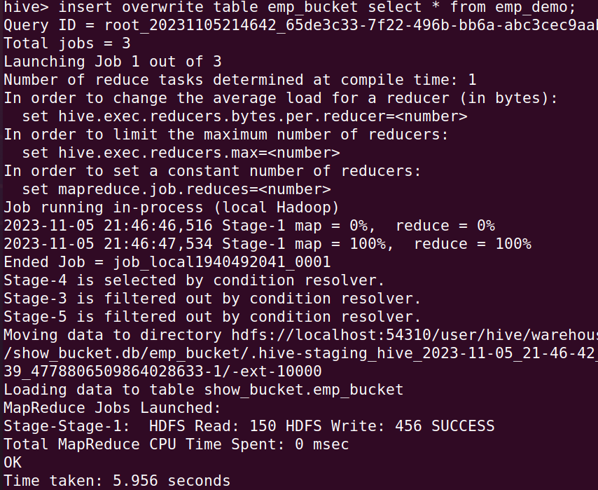

1. **Verify the output from terminal and browser**

quit;

hdfs dfs -ls /user/hive/warehouse/show_bucket.db/emp_bucket

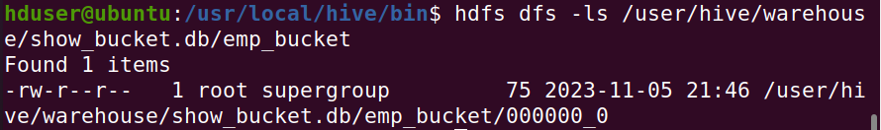

/user/hive/warehouse/show_bucket.db/emp_bucket

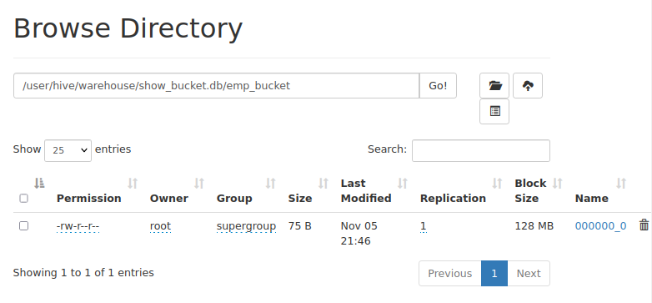

1. **Drop all tables &amp; database**

DROP DATABASE IF EXISTS student CASCADE;



DROP DATABASE IF EXISTS show_bucket CASCADE;

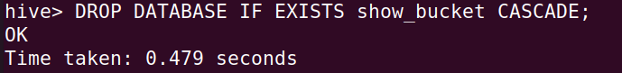

DROP DATABASE IF EXISTS company CASCADE;

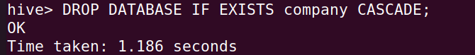

DROP DATABASE IF EXISTS school CASCADE;

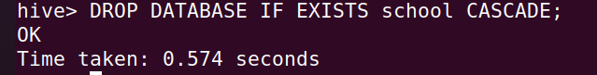

show databases;

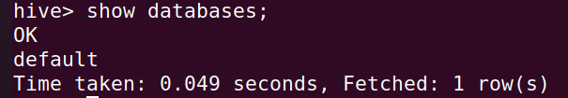

1. **Delete all files created in HDFS in this particular session only**

quit;

hdfs -dfs -rm -r /SDS



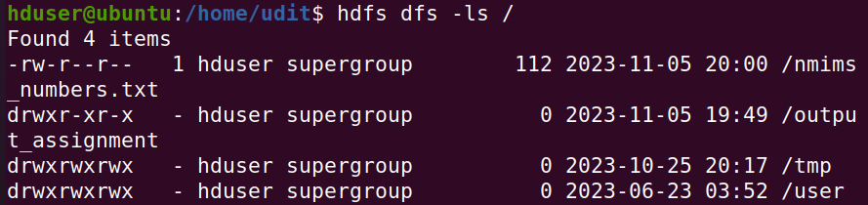

1. **Delete all files &amp; folders created in /usr/local in this particular session only**

cd /usr/local

sudo rm -rf sds_a016

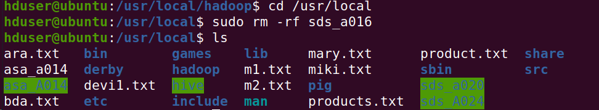

**Conclusion:** The practical for implementing bucketing in Hive was successfully completed.